NAME: SAHASRA V
REG NO: 192424234
COURSE: DSA-0504 QUERY PROCESSING FOR DATA SCIENCE
CO5-ACTIVITY 1

AIM
To implement and compare different Machine Learning classification algorithms using Python and evaluate their efficiency based on Accuracy, Precision, Recall, and F1-Score, with graphical visualization using the Matplotlib library.

OBJECTIVES
- To load and preprocess a suitable machine learning dataset.
- To implement different machine learning algorithms such as Logistic Regression, Decision Tree, Random Forest, K-Nearest Neighbors (KNN), and Support Vector Machine (SVM).
- To train and test the selected machine learning models.
- To calculate and compare Accuracy, Precision, Recall, and F1-Score for each model.
- To identify the best-performing machine learning algorithm based on the evaluation metrics.
- To create comparison charts using Matplotlib.
- To implement various Matplotlib functions such as bar charts, line graphs, scatter plots, pie charts, histograms, boxplots, grids, colors, markers, legends, annotations, and confusion matrices.
- To visually analyze the performance differences between the machine learning algorithms.
CODE:

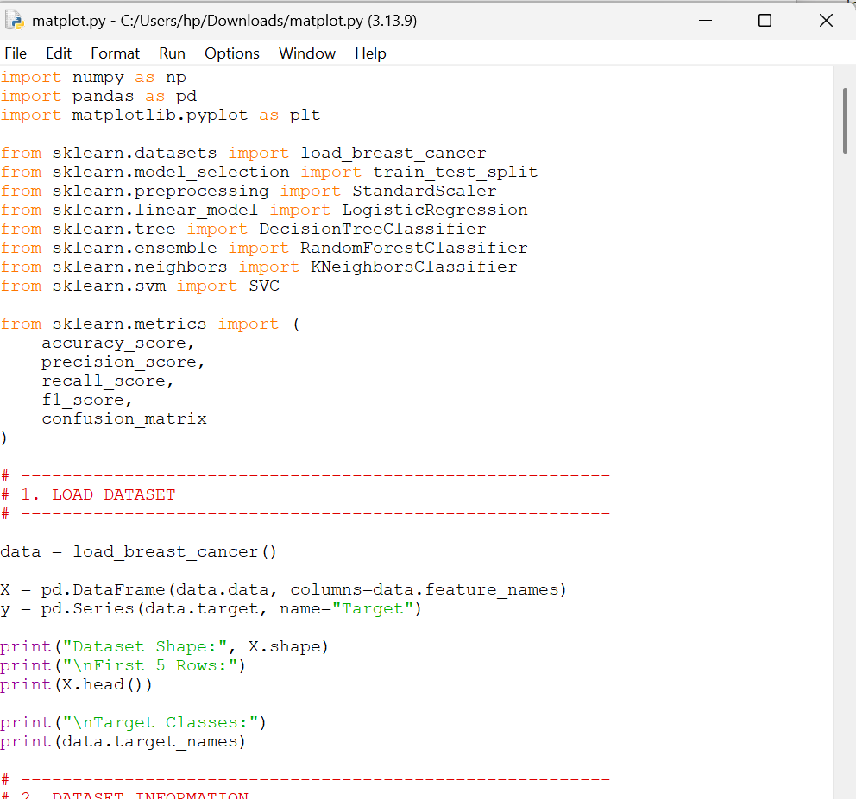

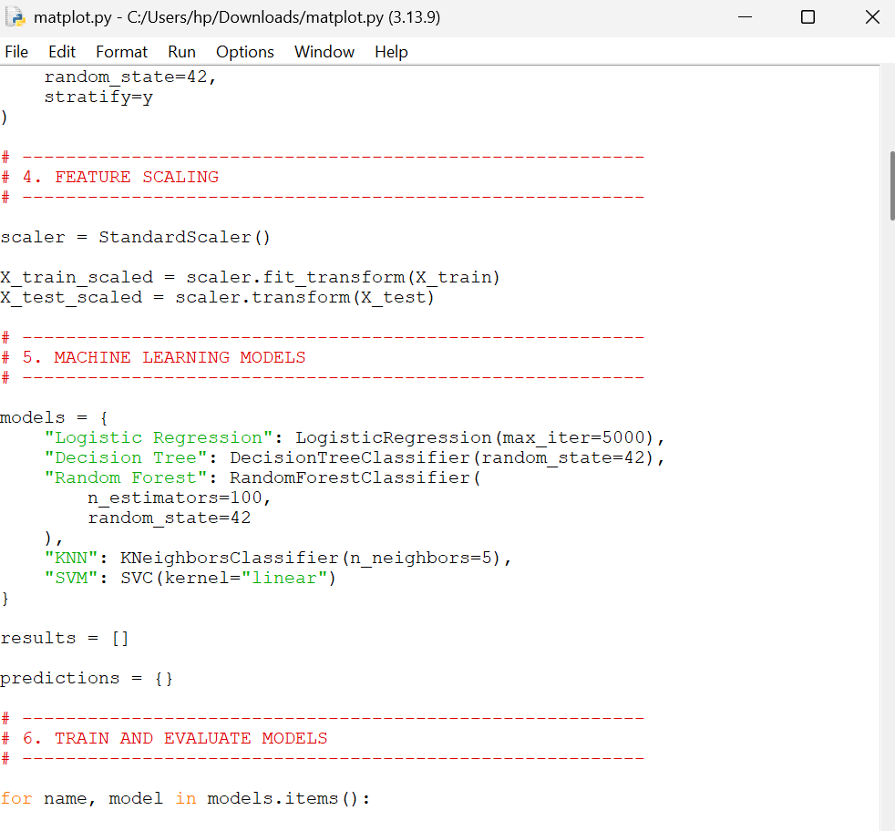

OUTPUT:

